**DATA ENGINEERING: REAL TIME DATA STREAMING**

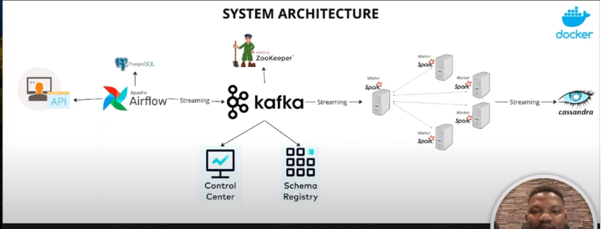

API : Randomuser.me